Mission
- Goat Specialist
- Admin

- 5,082 posts
- Gender:Male
- Location:Monroe, MI
- Interests:Scholarly piracy, designing and creating haunted house rooms and props, movies, abstract thinking, abstruse thinking, obstructive thinking, ideating, random thinking, movies, cartoons, movies, movies scores, cycling, world peace and small furry dogs, movies, writing, drawing, personal skills training, gremlins and, of course, lest I forget, movies.
(IP: 24.231.217.242) ·
Posted May 18, 2009 (edited) · Report post
While this book [Maritime Quarantine: The British Experience c. 1650 -1900 by John Booker] does not contain as much about the medical aspects of maritime quarantine as I had hoped it would, it is sort of interesting how political the whole thing was. A lot of the various periods of quarantine and importing countries subject to quarantine seem to have had as much, if not more, to do with personal political agendas than they did with health. Then there are the aspects of local enforcement (apparently strict for some, lax for others) and the paperwork, fees and appeals required to be certified to leave quarantine for some, but not all.
Edited May 23, 2009 by Mission

- Quote
- Edit

Mission
- Goat Specialist
- Admin

- 5,082 posts
- Gender:Male
- Location:Monroe, MI
- Interests:Scholarly piracy, designing and creating haunted house rooms and props, movies, abstract thinking, abstruse thinking, obstructive thinking, ideating, random thinking, movies, cartoons, movies, movies scores, cycling, world peace and small furry dogs, movies, writing, drawing, personal skills training, gremlins and, of course, lest I forget, movies.
(IP: 64.241.37.140) · ·
Posted May 23, 2009 (edited) · Report post
I thought some of you interested in clothing might find this a little interesting:
"Yet the European perception that some goods were more ‘susceptible’ to harbouring disease than others was certainly understood in England. Cloth was thought one of the most deadly transmitters: this is why the linen ships from Morliax were targeted in 1638, and why textiles from Colchester were to be aired at Stratford in 1666. Any fibrous material, including hemp and flax, was reckoned highly contagious, although tar and pitch were thought to form an effective barrier. Thus the cordage at Yarmouth was susceptible but not when tarred. In the years ahead the division into susceptible and non-susceptible goods was to be a science in itself, with every conceivable import placed in one category or the other, with grades of susceptibility.” (Booker, p. 15-6)
“The most interesting aspect of the Scottish measures lies in the insistence that cargoes should be ‘cleansed’, either by the very radical measure of immersion in sea water for a day or two, or by opening and airing. In this respect the country
__
was nearer to the Continental practice than was England where, for lack of a convenient airing ground in the Thames estuary, and for the insouciance of the Privy Council about what happened in the outports, the focus was on quarantine itself.” (Booker, p. 24-5)
Edited May 23, 2009 by Mission

- Quote
- Edit
- Options

LadyBrower
- Pyrate Captain
- Member

- 582 posts
- Gender:Female
- Location:Walden, NY
- Interests:Sewing, Crochet, Knitting, Reading, Cooking, Baking, Yoga, Kickboxing, Bellydance, Guitar Hero, Rockband
(IP: 69.206.131.239) · ·
Posted May 23, 2009 (edited) · Report post
Strangely, I have a fascination with plagues and such (Maybe it's fear?) and spent a good deal of time studying the outbreak of plague during the middle-ages... If I recall correctly, they really began the practice of quarantine in the 1300's with lepers.
According to Plagues and Peoples by William H. McNeil (an AWESOME book!) Naval quarantines were institutionalized in 1465 in Ragusa and the in 1485 Venice. The ship was required to remain in a secluded area for 40 days without communication. If people died of the plague, they were not allowed into harbor, if after the 40's if the crew was in good health, they were able to continue there business.
This marked a cultural revolution really, where people began to understand the spread of infection a little more. Unfortunately, not enough and did not adequately understand the roles of lice and rats in the transmission of the plague...
The book also says that quarantine practices had less of an effect on the prevention of the spread of disease as unitentional cultural changes such as the change in building materials after the great fire in London in 1666 where there was a change from thatched roofs and wooden structures to brick buildings (as a result of wood shortages).
I'm sorry, this probably doesn't help much, but I find it fascinating. I deffinately recomend the book as it does speak on the effect of the plague throughout history (1950's chinese outbreak is VERY interesting).
I'll look into it a little more on the medical stuff...
Edited May 23, 2009 by LadyBrower

- Quote
- Edit
- Options

Mission
- Goat Specialist
- Admin

- 5,082 posts
- Gender:Male
- Location:Monroe, MI
- Interests:Scholarly piracy, designing and creating haunted house rooms and props, movies, abstract thinking, abstruse thinking, obstructive thinking, ideating, random thinking, movies, cartoons, movies, movies scores, cycling, world peace and small furry dogs, movies, writing, drawing, personal skills training, gremlins and, of course, lest I forget, movies.
(IP: 64.241.37.140) · ·
Posted May 24, 2009 (edited) · Report post
I'm not saying the process of quarantine is not interesting, I'm saying the book I'm reading is not interesting. This book reads like stereo instructions.
My interest was in the role of the ship's surgeon in the quarantine process - particularly in obtaining pratique. Unfortunately, they appear to have had no role in the English version. I have some other notes where they were involved in a minor way at the Italian ports. Yonge gives a fun description in his Journal:
“We came up close to the mouth of the haven of Messina, and sticking the ship ashore under the trees, ran hastily with a halser and fastened to one of them… After we had been a while there, no one suffered to come ashore, we are all hands called out of the ship and directed to a small quadrangle, where an old fellow, perusing the bill of health we had from Genoa, puts on a great pair of spectacles as big as saucers and, making each man expose his groins and armpits, he looks into them and with a stick thrusts in them, where, finding nothing, we are allowed prattick [pratique], and then went into the town. One of our men who came from Genoa with a bubo [from Gonorrhea] was quite cured, for I purged and sealed it off, so as he was well and nothing showed but the want of hair, tho our man earnestly lookt into it and see if he could find what he suspected.” (Yonge, p. 75)
Edited May 24, 2009 by Mission

- Quote
- Edit
- Options

Mission
- Goat Specialist
- Admin

- 5,082 posts
- Gender:Male
- Location:Monroe, MI
- Interests:Scholarly piracy, designing and creating haunted house rooms and props, movies, abstract thinking, abstruse thinking, obstructive thinking, ideating, random thinking, movies, cartoons, movies, movies scores, cycling, world peace and small furry dogs, movies, writing, drawing, personal skills training, gremlins and, of course, lest I forget, movies.
(IP: 64.241.37.140) · ·
Posted May 24, 2009 · Report post
Ah, found another quote related to quarantining goods coming into England. I thought the details about importing skin for leather and hair for wigs was kind of interesting.
"It remains to consider one more aspect of quarantine in the Marseilles emergency [1720-1723], which was the airing of kid and hare skins, and human hair. This was an issue to which the Privy Council paid close attention, as medical opinion held that skin and
__
hair were especially prone to harbour infection. Skins were sometimes imported in ships which were liable to quarantine anyway, but in the great majority of cases they formed part of a cargo in vessels from the near Continent, especially Hamburg, Amsterdam and Rotterdam. As these ships were not themselves detained, they do not form part of the statistics of quarantine... Most of the skin and hair went to the Red House at Deptford, which has already een discussed. Skins were imported in vast quantities for the leather trade; as many as 28,000 in one consignment, sometimes spread between two ships, and packed in bales, casks or 'fatts'. Other skins were imported through Ireland, which did not exempt them from the quarantine restrictions. Human hair for wig and peruke makers was imported generally in quantities of 50 to 70 lbs, packed into bag or barrels, although 500-lb cargoes were not unknown."

- Quote
- Edit
- Options

Mission
- Goat Specialist
- Admin

- 5,082 posts
- Gender:Male
- Location:Monroe, MI
- Interests:Scholarly piracy, designing and creating haunted house rooms and props, movies, abstract thinking, abstruse thinking, obstructive thinking, ideating, random thinking, movies, cartoons, movies, movies scores, cycling, world peace and small furry dogs, movies, writing, drawing, personal skills training, gremlins and, of course, lest I forget, movies.
(IP: 24.231.217.242) · ·
Posted May 26, 2009 (edited) · Report post
This is a list of goods that were in quarantined ships coming into England from 1709-1714 from Booker's Book. While even the author notes that the accuracy can be easily questioned (records were spotty at best), I thought it did present an interesting assembly of things being imported. It gives a small insight into what pirates may have encountered when they took vessels. Note that most of these cargoes were coming from the Baltic, however.
I admit I am a trifle confused by the heading on the columns. If I understand it rightly, it indicates how many cargo items ships had when they were quarantined. The foot notes and an explanatory paragraph about the meaning of some of the commodity words is included at the end.
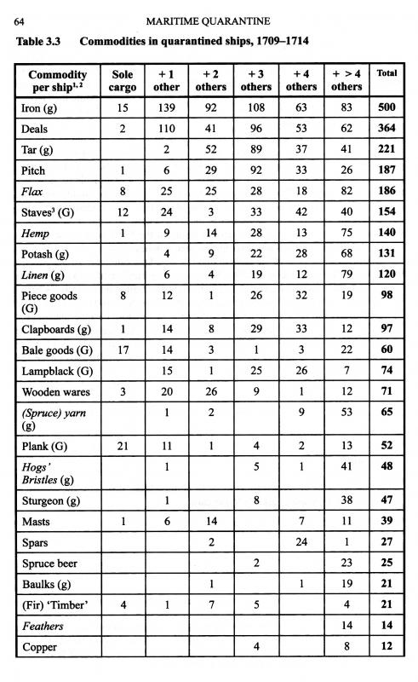
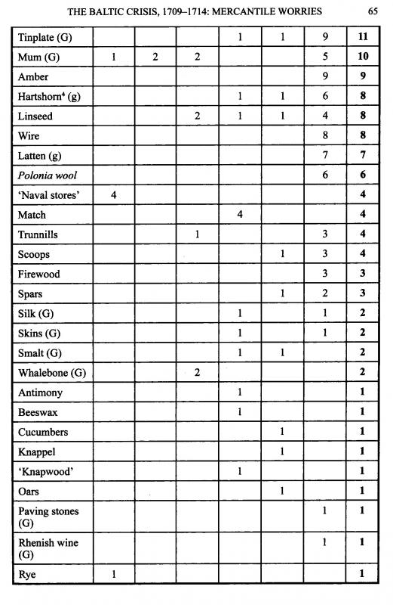
"Notes:
(1) Items italicized were 'enumerated' as particularly liable to convey infection.
(2) (G) means the product was imported from the German North Sea ports; (g) means the product was essentially from the Baltic, but also imported from Germany
(3) The term 'staves' includes hogshead, barrel and pipe-staves.
(4) Hartshorn includes buckhorn.
Sources: NA PC 2.82-4; Calendar of Treasury Books, vols 24-8; NA SP 44/245 and CUST 99/1; Hull City Archives WB 8,9
The usual caveat applies: that the information is only as good as the details which were entered in contemporary records...
The term 'bale goods' was ambiguous, as it could refer to any cargo not classified as 'case' goods, but there was much more at stake than naval stores. Potash was used by soap-makers. Deals had a market in the building trade, and staves, although very much in demand for shipboard barrels, had a wide sale among coopers. Clapboards, although sometimes used also for barrels, were the material for wainscoting. Lampblack, or blacking, was used to make ink. Mum was a German beer. Smalt was a blue class crushed to make pigments. But the temporary absence of such minor commodities would not have sent ripples through Government as did naval stores. It is worth noting that one cargo of rye (imported to Newcastle) is the only significant foodstuff in the list, although the Danish prize Helena, forced to do quarantine in Stangate Creek, carried a cargo of corn which the prize agent was anxious to sell." (Booker, p. 66)

